08/06/2015

Linked Tables and ODBC Setup

Here is the ODBC setup. To get to this screen, from the start menu, search for ODBC, and click on Data Sources (ODBC). Click on the SystemDSN tab. This screen is flaky, and the System Data Sources may disappear. To put them back, click Add… Note: if you don’t already have the MySQL ODBC 5.3 ANSI driver, download the MSI file and install.

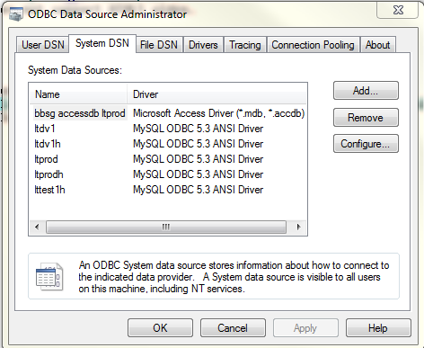  
Here is the setup for the development database.

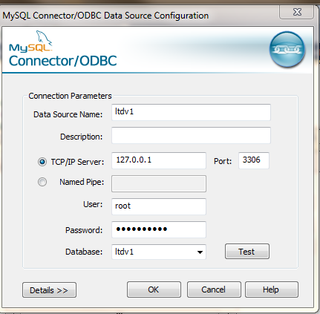

Here is the setup for the test database on Hostek.

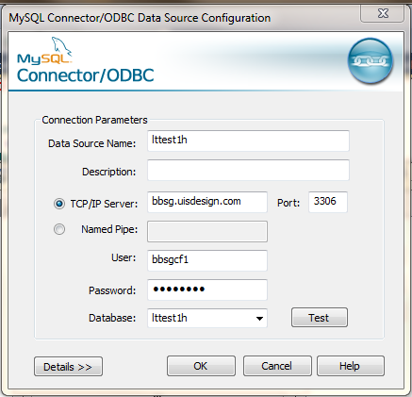

Pwd is .Nogo123